Business Plan

OGCJM



Burlacu Vanesa-Beatrice

S3

Introduction:

Business name and why was it chosen:

‘OGCJM’ which is the name of the shop was chosen because the items of the shop are based on the 80’s 90’s style, the name of the shop is a short form of ‘Only God can judge me’, which is a name of a song that the rapper from the 90’s Tupac Shakur wrote.

Business aims:

The aim of the shop is to reach maximum profit so we can invest in our items, besides that we can offer useful products and good customer service so that our costumers are happy with the products that we offer.

Business location:

The location of the shop is going to be on Princess Street in Edinburgh, so it can be easy for people that live here or people that are just visiting to locate it and in my opinion, Princess Street it’s the most visited street, because of the shops that are located there and the beautiful view of the park.

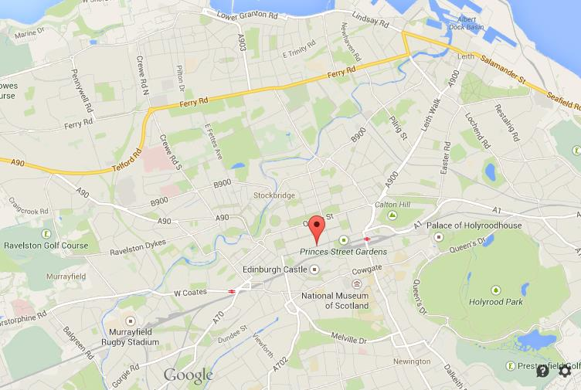

Ownership structure:

Product/Service and Market:

The product:

The shop offers useful products, such as chlotes, house items, CD s, accessories, posters, etc. The purpose of the shop is to offer items that are from the late 80,s and 90,s. You can find here rare things as well, for example a painting that it’s worth so much money and you buy it on a god price.

Market being targeted:

Size of market:

Methods of promotion:

Human resources:

Employees required:

The shop requires a cashier, some helpers and a manager so that the shop would be under control and if you have any problems we can help you.

Duties and skills required:

Hours of work:

The program will be the following one

Mon 8:30am-16:30pm

Tue 8:30am-16:30pm

Wed 8:30am-16:30pm

Thu 8:30am-16:30pm

Fri 9:30am-15:30pm

Sat 9:30am-15:30pm

Sun -closed-

Remuneration arrangements:

Premises and equipment:

Equipment required:

|  |  |  |
| --- | --- | --- |
| Item | Purchased from | Cost |
| Wall shelfs x8 | Stainless | £256 |
| Shelfs x10 | Ebay | £1050 |
| Reception desk | Office furniture | £420 |
| Hanger stand | Ikea | £70 |
| Hangers 8x20 | Ikea | £70 |
| Chairs x4 | GamFratesi | £3468 |
| Storage baskets x30 | Compacor | £315 |
| Box storage 6x30 | Storage for office, crafts and home | £13548 |
| Sofa x2 | Love sofas | £490 |
| Mini fridge | Hudson’s office furniture | £199   |  | | --- | | Total: £19,894 | |

Details of premises: